A000-Afr-Nigeria-Yoruba-Mask-Mid 20th c

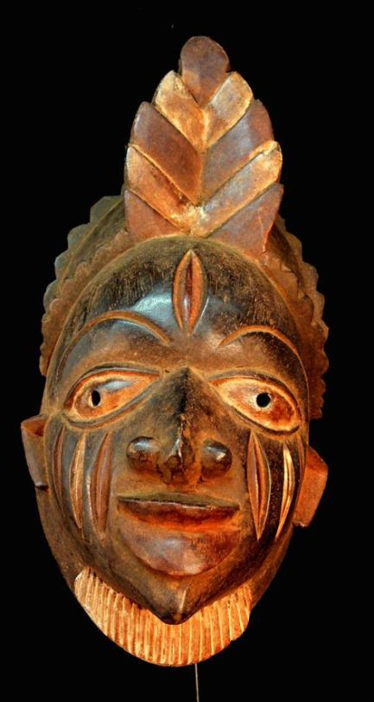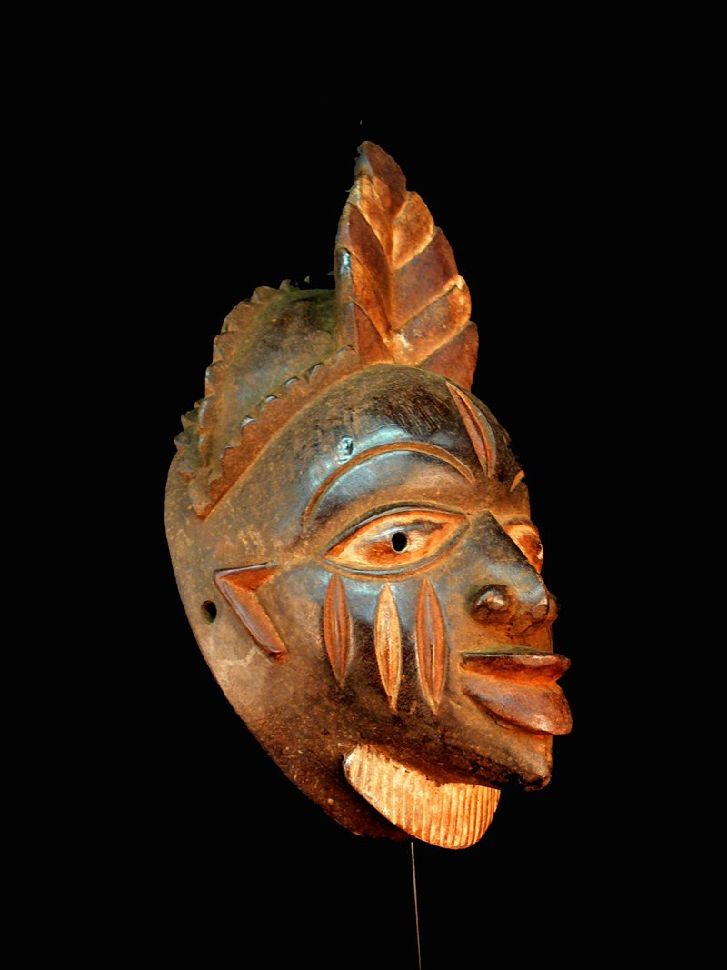

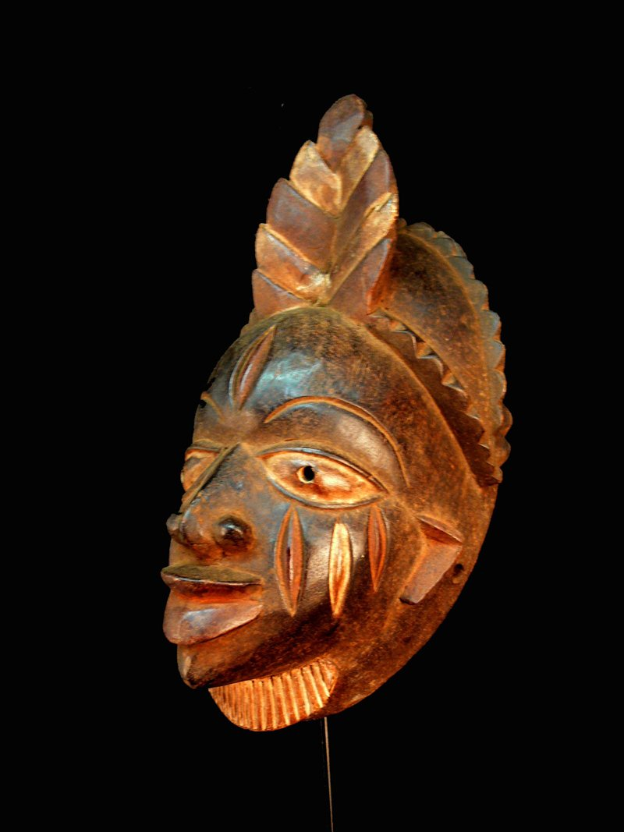 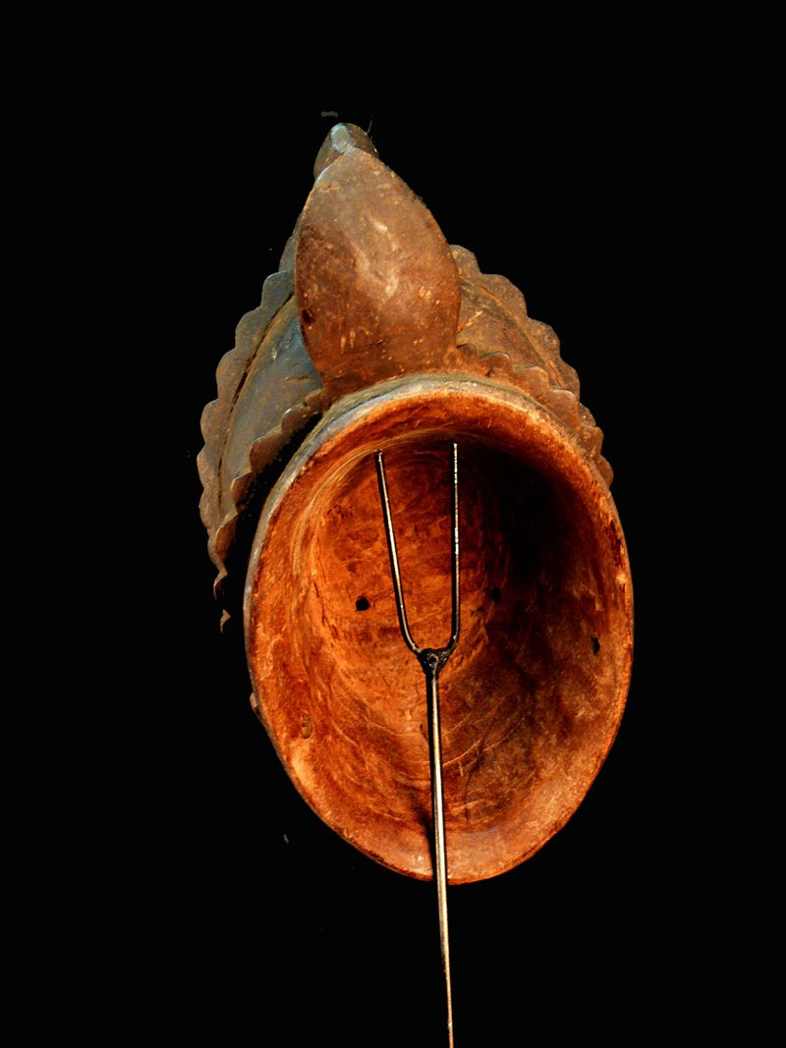

Figs. 1-4. Afr-Nigeria-Yoruba-Mask-Mid 20th c

Case No.: 6

**Accession No.**

**Formal Label:** Afr-Nigeria-Yoruba-Mask-Mid 20th c

**Display Description:**

**LC Classification:**

**Date or Time Horizon:**

**Geographical Area:**

**Map:**

**GPS coordinates:**

**Cultural Affiliation:**

**Media:**

**Dimensions:** 14.173 inches;

**Weight:** : 2.125 pounds

**Condition:**

**Provenance:**

**Discussion:**

**References:**